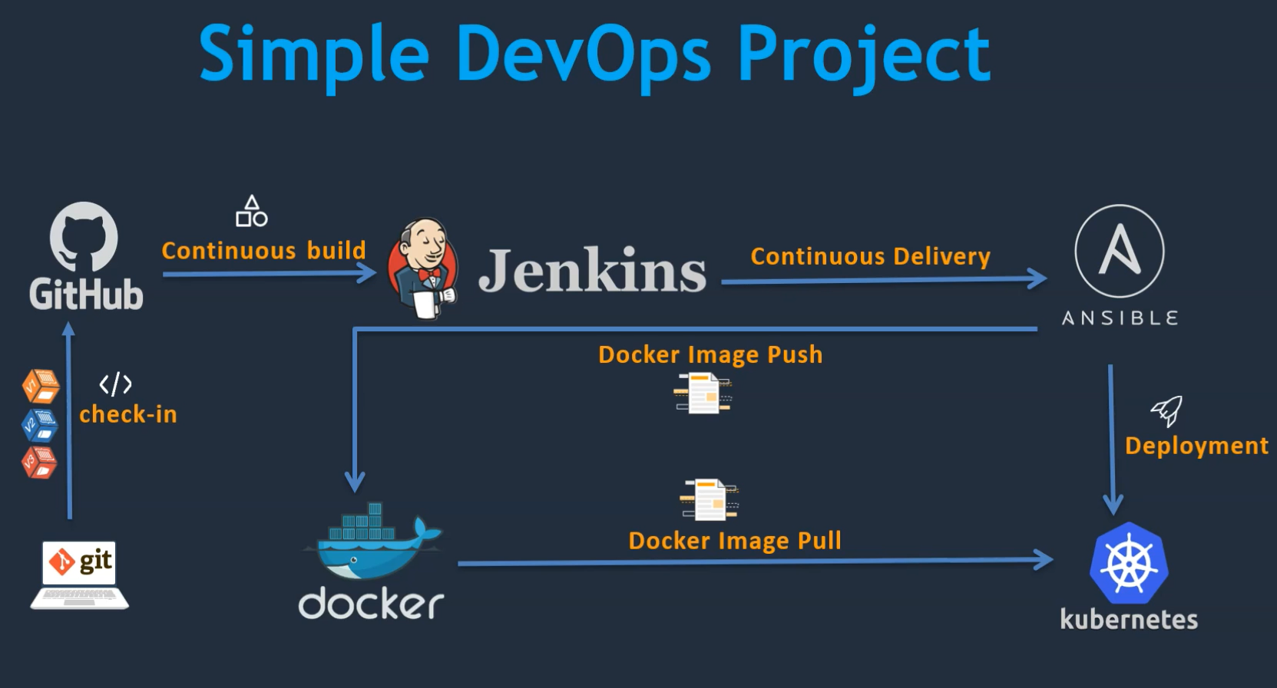

Deploy artifacts on VM

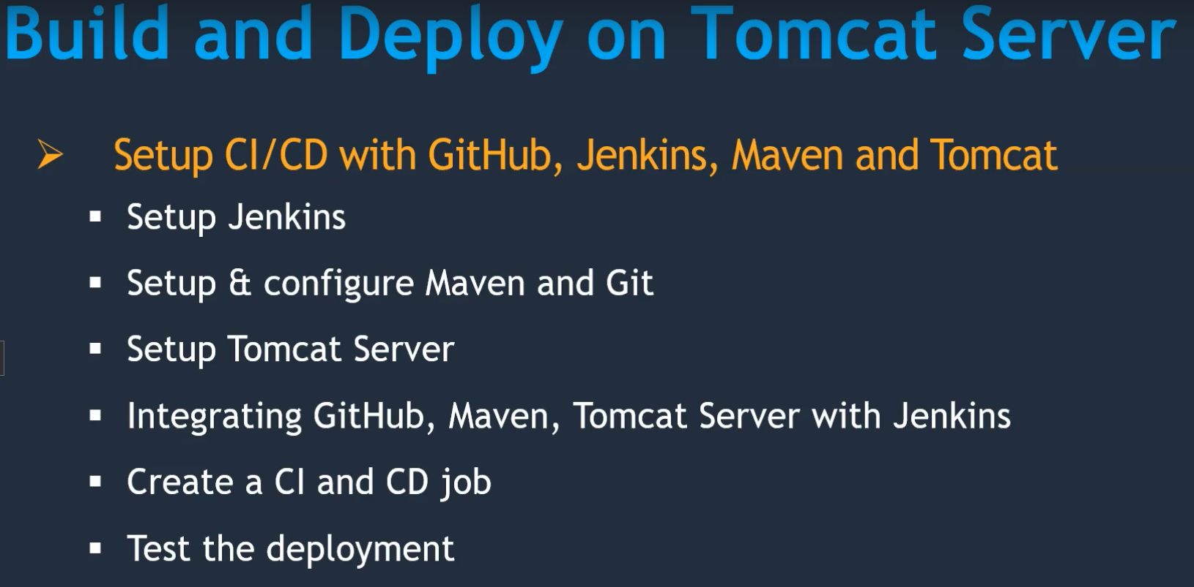

Second phase deploy artifacts on tomcat server.

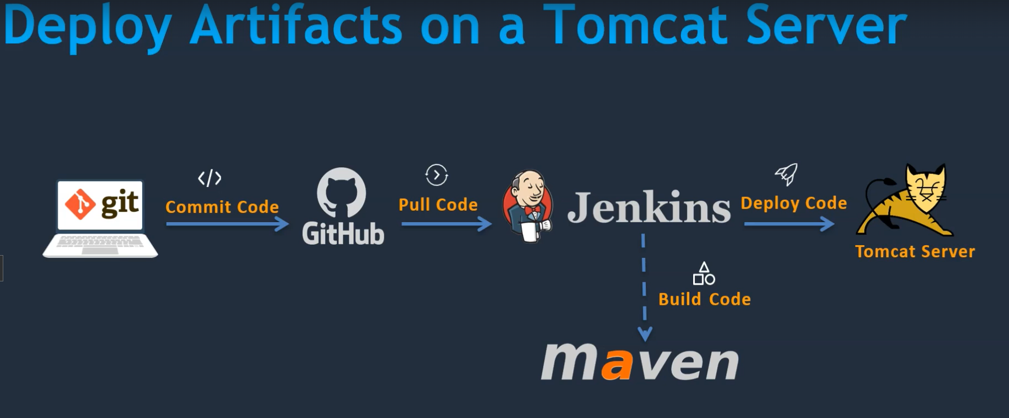

2. Deploy artifacts on a container

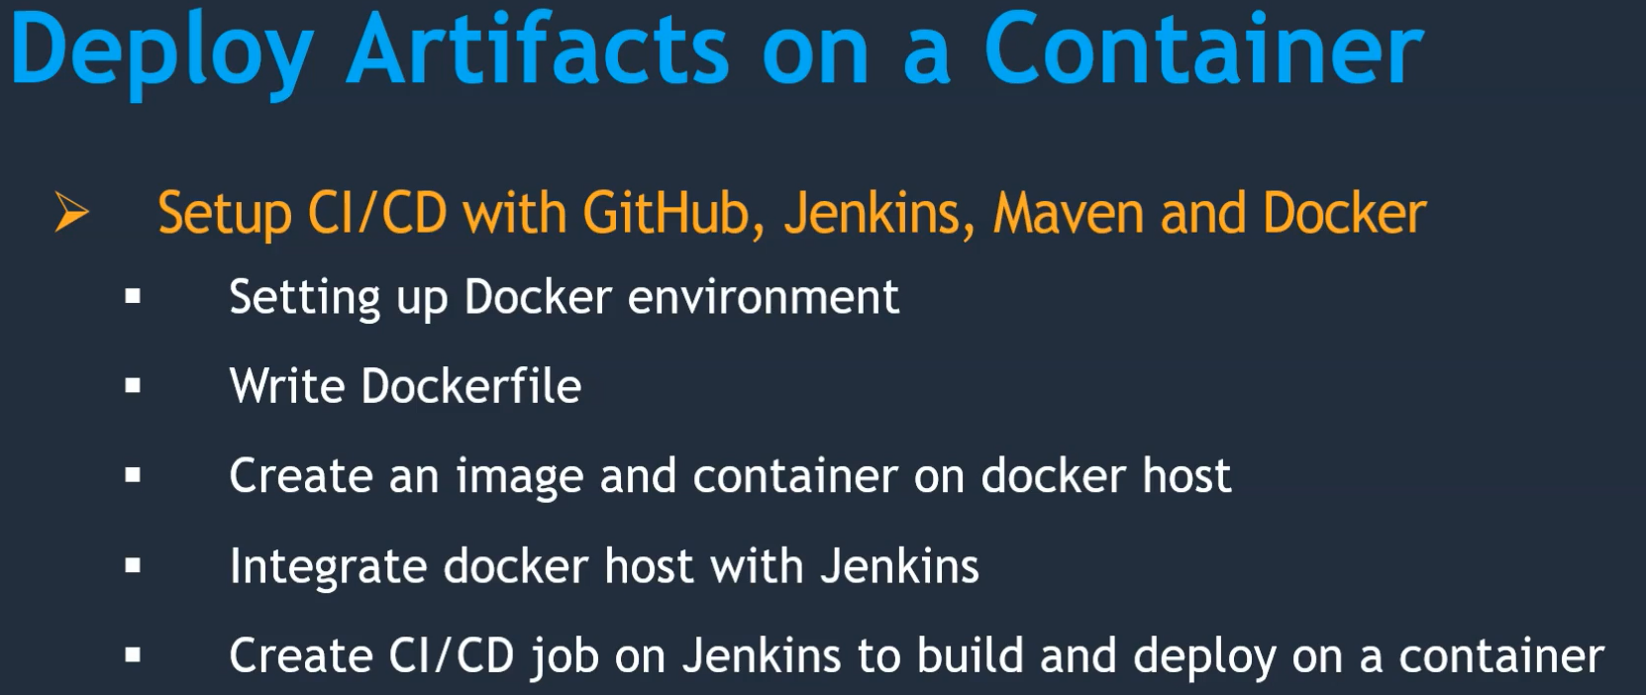

Simple DevOps Project

* Continuous Integration (CI)
* Continuous Delivery (CD)
* Continuous Deployment (CD)

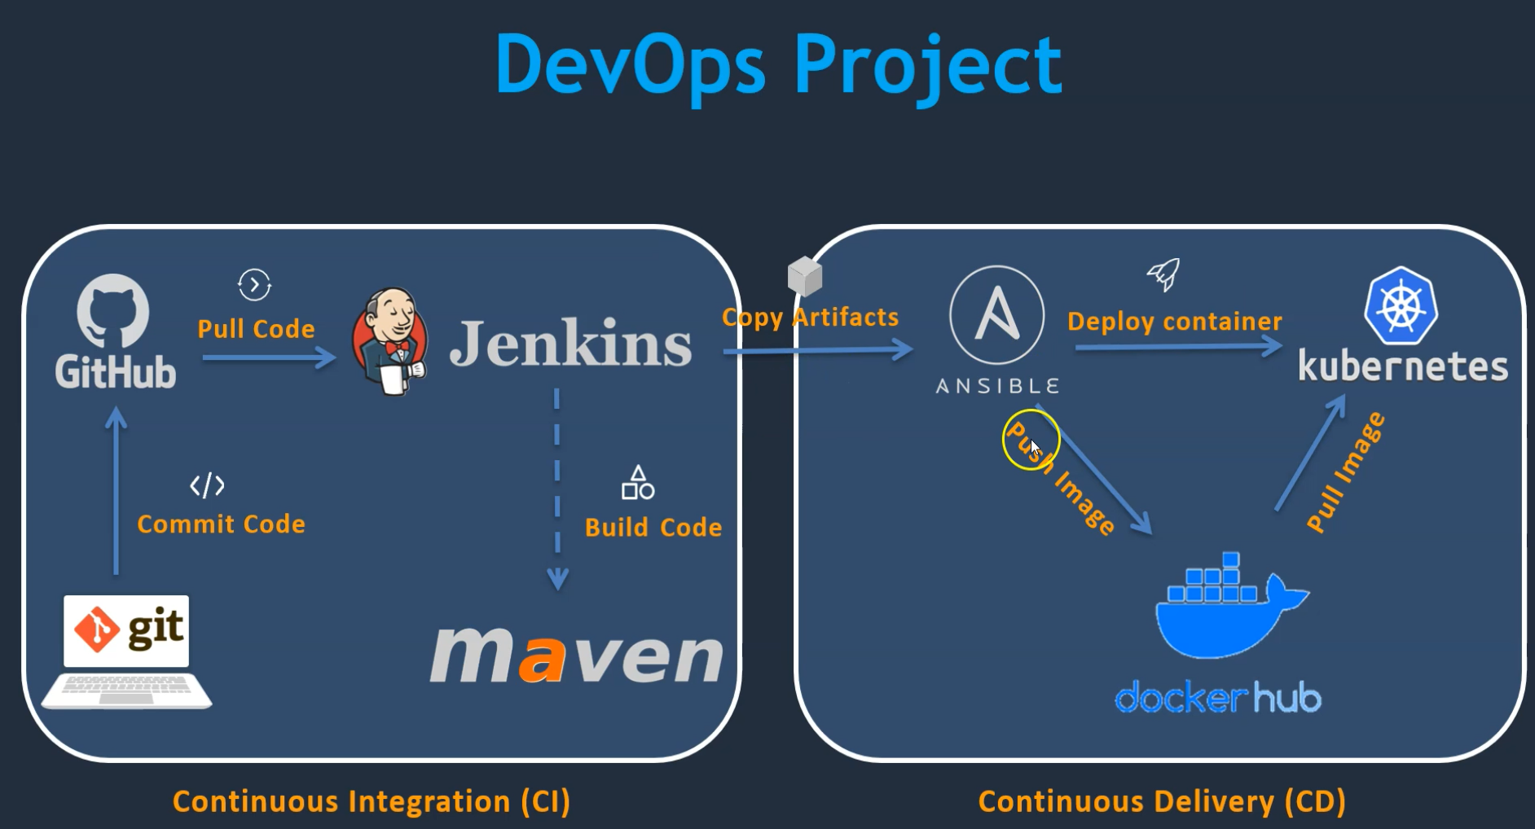

FOR DOCUMENT

[bunty4200/Udemy-Simple-DevOps-Project: Udemy_Course_Project (github.com)](https://github.com/bunty4200/Udemy-Simple-DevOps-Project)

SOURCE CODE

[bunty4200/Udemy-hello-world: Udemy_Course_Project (github.com)](https://github.com/bunty4200/Udemy-hello-world)

STARTING

1. Step

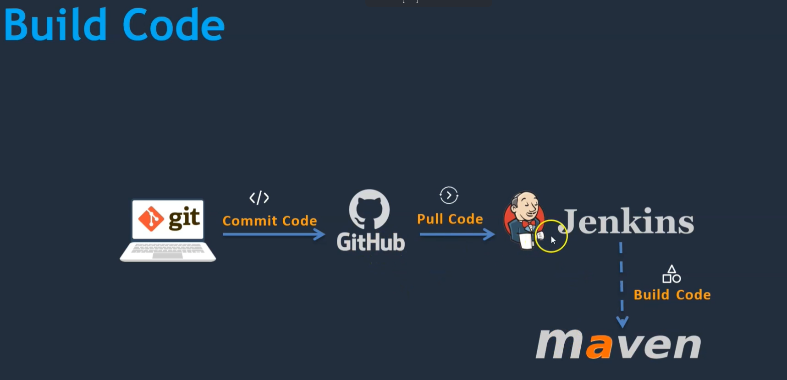

Chose AMAZONE LINUX 2

2. Setup Jenkins Server

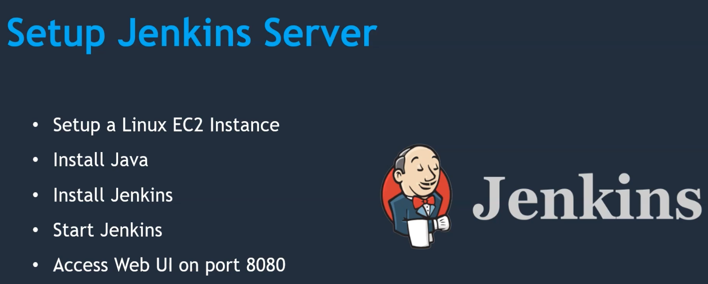

3. Create EC2 instance Amazon Linux 2.

Add port number 8080 to the security group.

4. Install Jenkins

[Linux (jenkins.io)](https://www.jenkins.io/doc/book/installing/linux/#red-hat-centos)

sudo wget -O /etc/yum.repos.d/jenkins.repo \  
 <https://pkg.jenkins.io/redhat/jenkins.repo>

sudo rpm --import <https://pkg.jenkins.io/redhat/jenkins.io-2023.key>

sudo yum upgrade

sudo amazon-linux-extras

amazon-linux-extras install java-openjdk11

yum install jenkins

systemctl daemon-reload

systemctl enable jenkins

systemctl start jenkins

systemctl status jenkins

5. Browse publicIP with Port Number 8080 to access Jenkins UI

6. skip Install suggested plugins click on right nd side cross symbol

7. click on start using Jenkins.

Run first job in jenkins

Helloworldjob

Uptime

echo “Hello world”

8. Integrate Git with Jenkins

Pull the code from GitHub we need install git on Jenkins

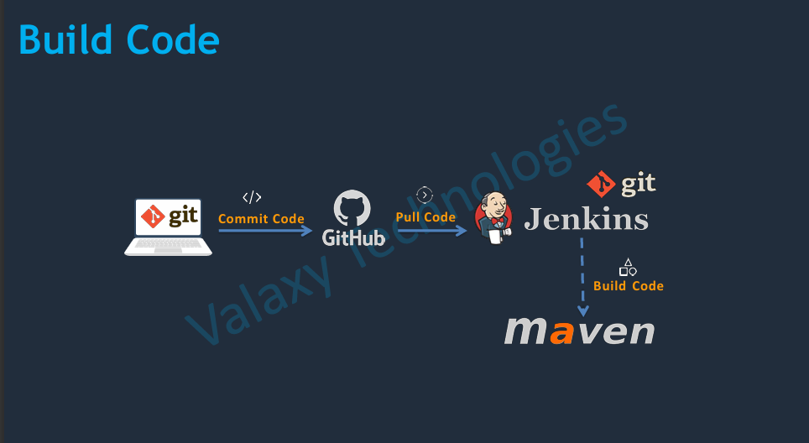

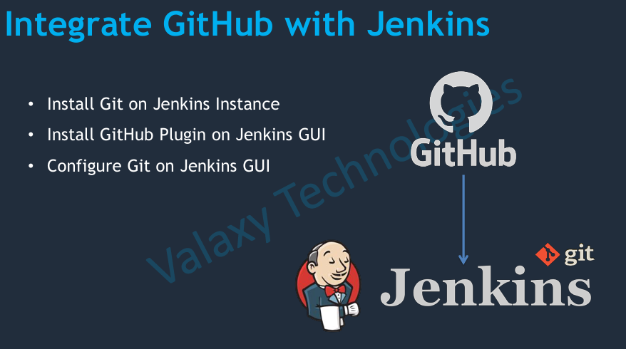

Install Git on Jenkins Instance

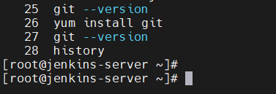

Install GitHub Plugin on Jenkins GUI

Dashboard > Mange Jenkins > Plugins > available plugins > github > install

Configure Git on Jenkins GUI

Dashboard > Mange Jenkins > tools > git

Name git

Path to Git executable

git or using command whereisgit in Jenkins instance it will show the executeble path

9. Run Jenkins job to pull the code from GitHub

Create new job

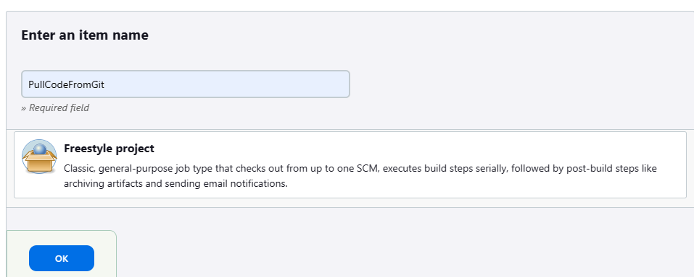

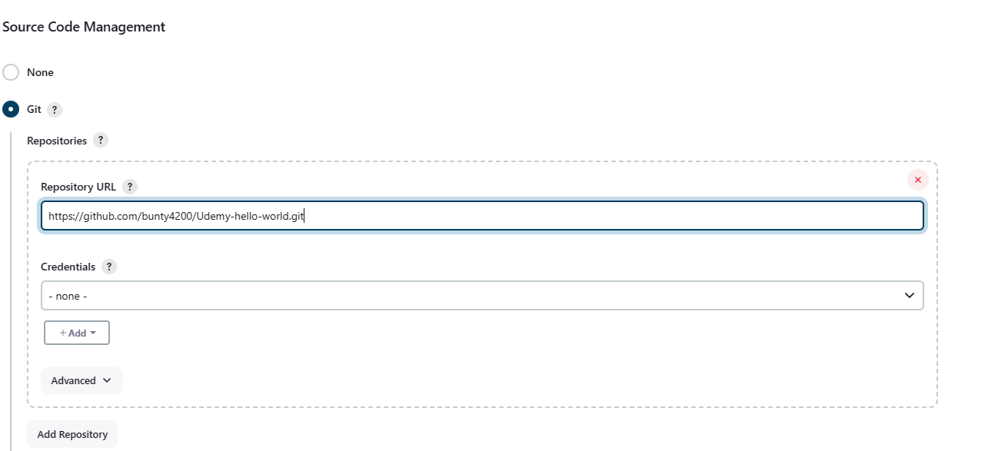

Apply and save and build job.

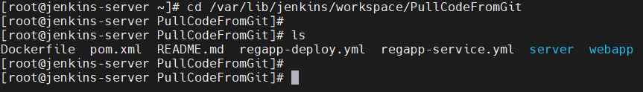

10. Integrate maven with Jenkins

Setup Maven on Jenkins server

Download maven [Maven – Download Apache Maven](https://maven.apache.org/download.cgi)

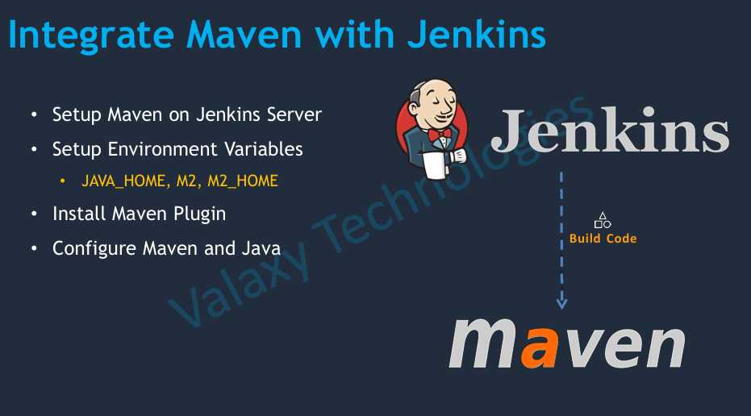

Setup Maven on Jenkins server

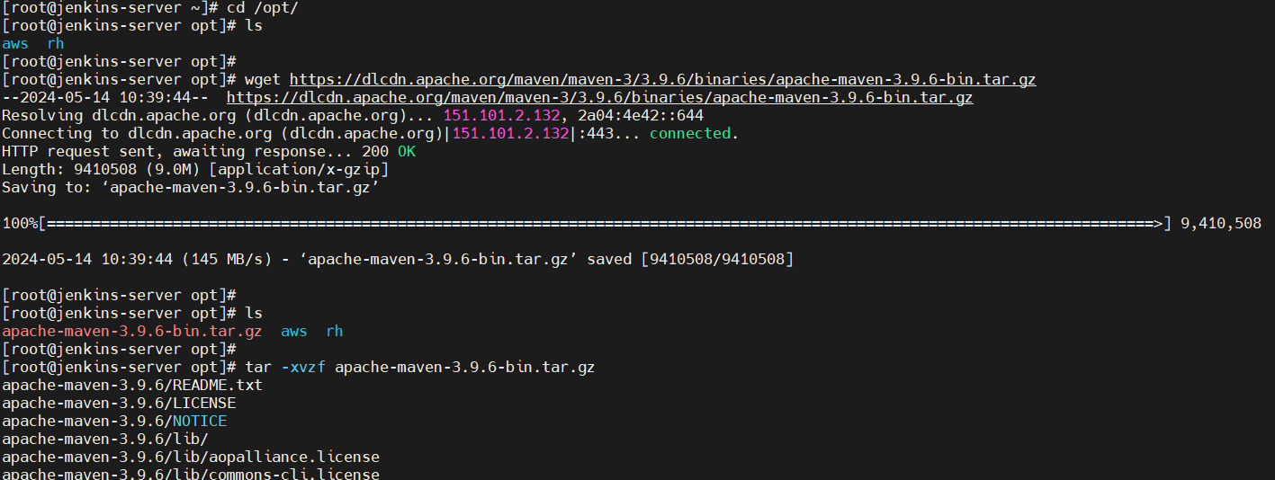

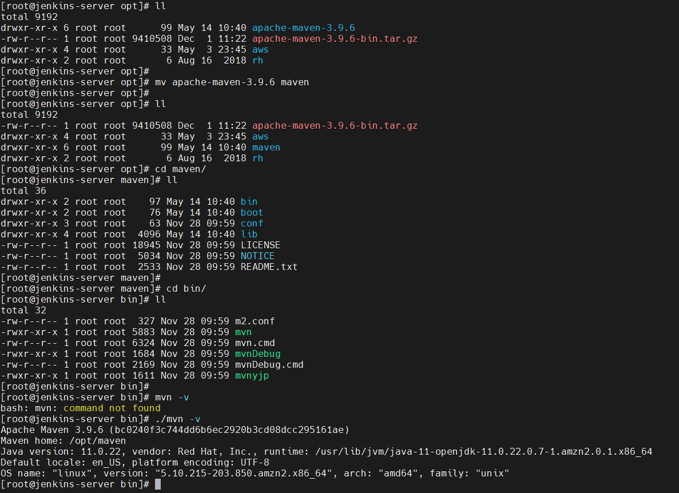

./mvn -v i could able to execute in maven folder but i could not be able to execute to maven

So for that we need to set it up env variable under .bash rc or set it up environment directory.

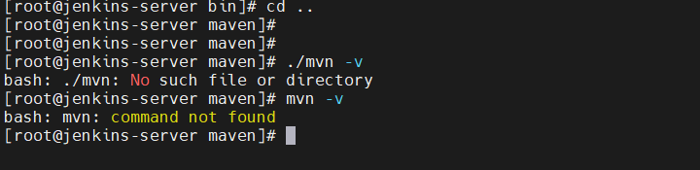

11. Setup Environment Variables • JAVA_HOME, M2, M2_HOME

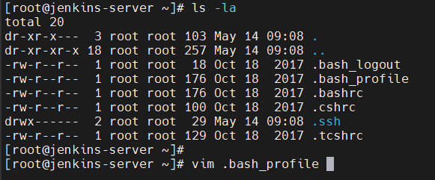

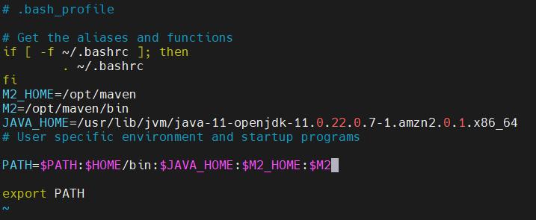

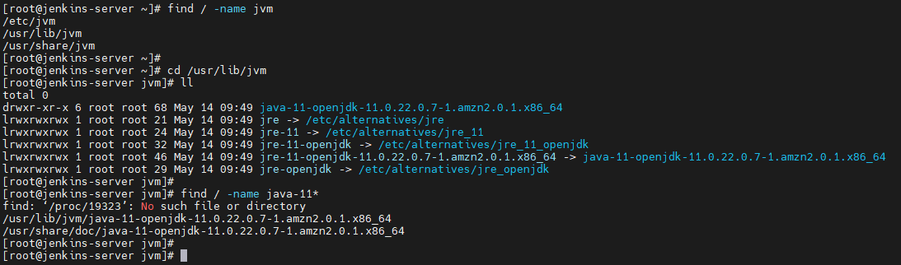

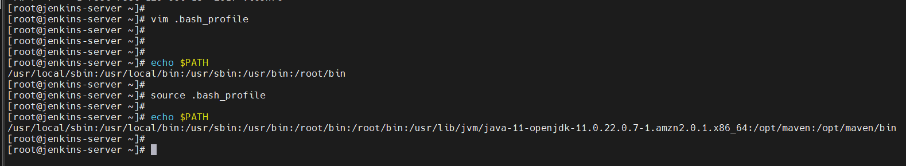

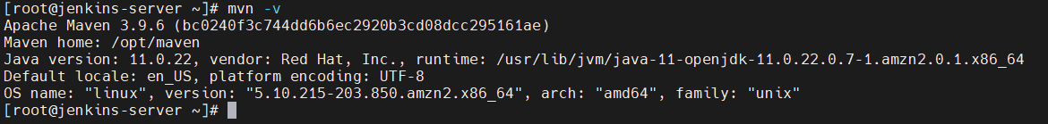

12. Install Maven Plugin

Dashboard > Manage Jenkins > Plugin > Maven Integration

After that configure Jenkins with maven

Dashboard > Manage Jenkins > Tools

Add java JAVA_HOME in tools

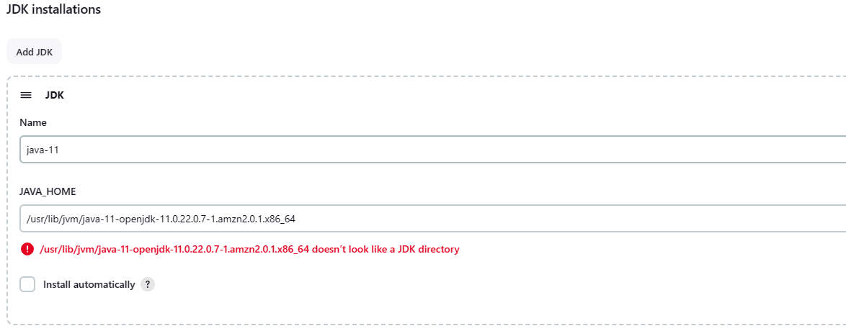

Maven path in tools

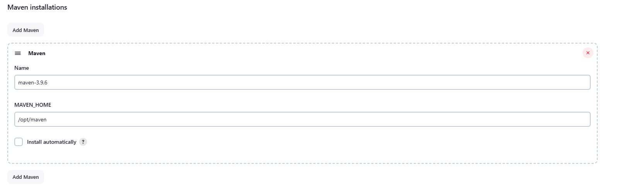

13. Build a java project using Jenkins

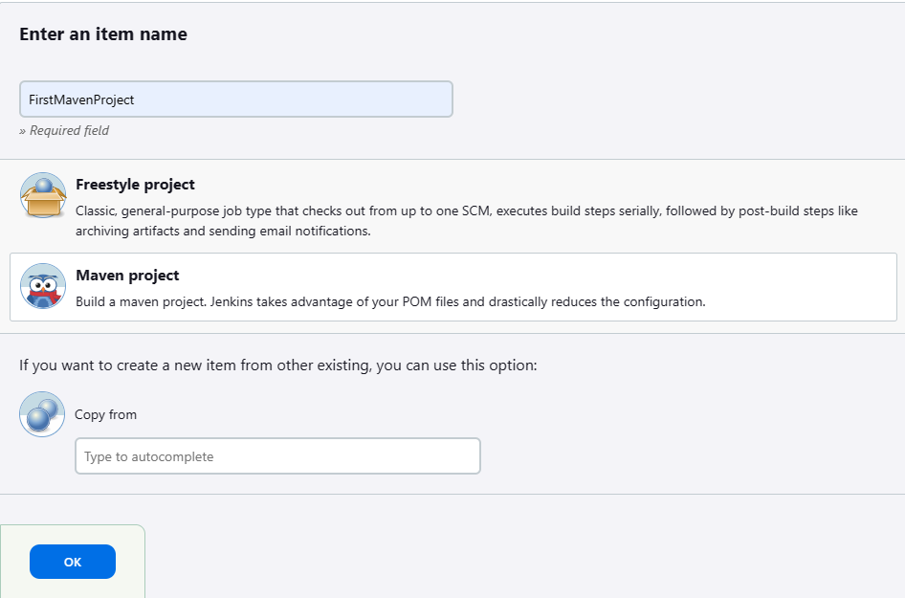

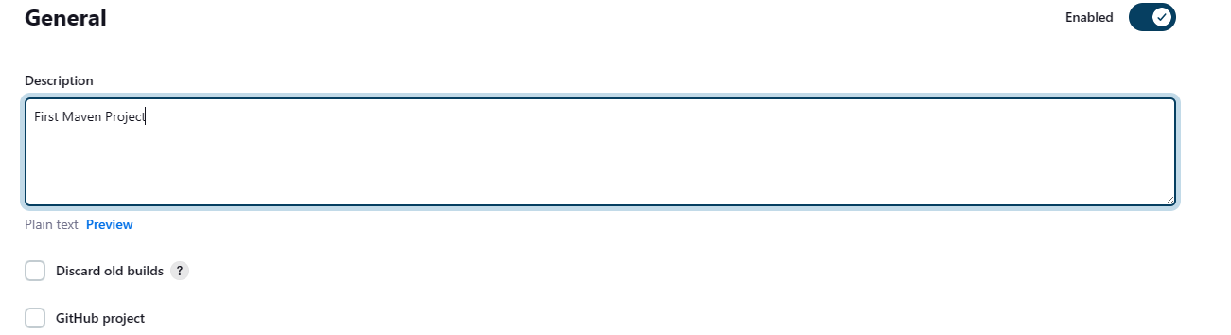

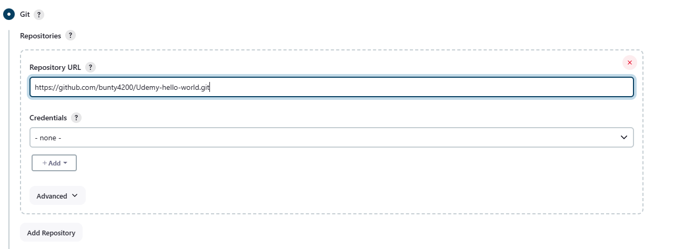

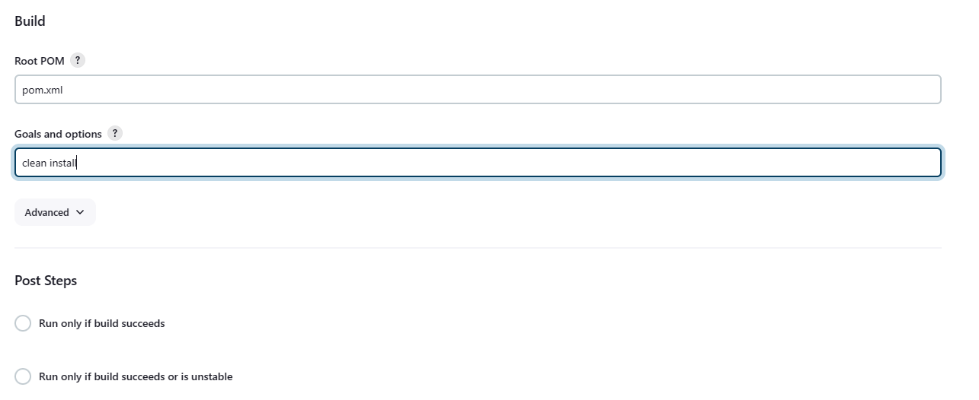

Save and Build

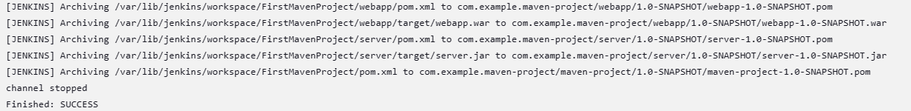

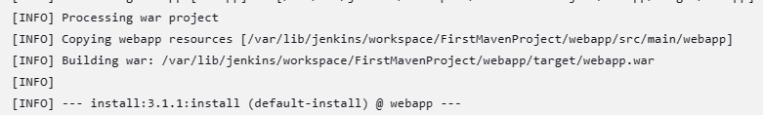

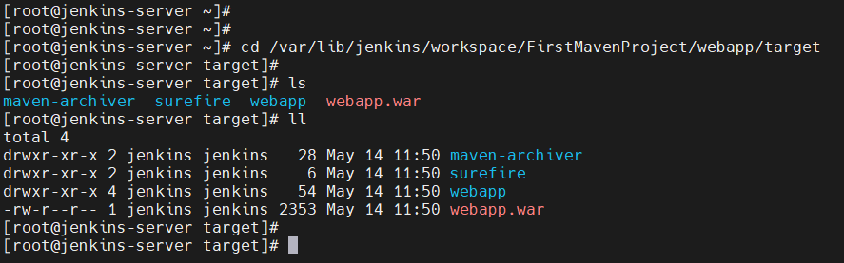

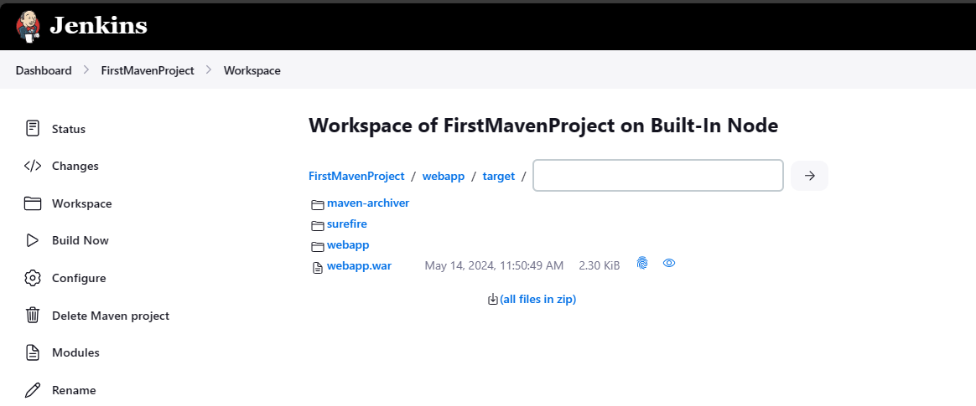

So far we have created artifacts.